<https://github.com/sathishk/sathishk.github.io>

use this tempelate

git submodule add -f <https://github.com/techatpark/my-resume.git> themes/my-resume

//have to add above

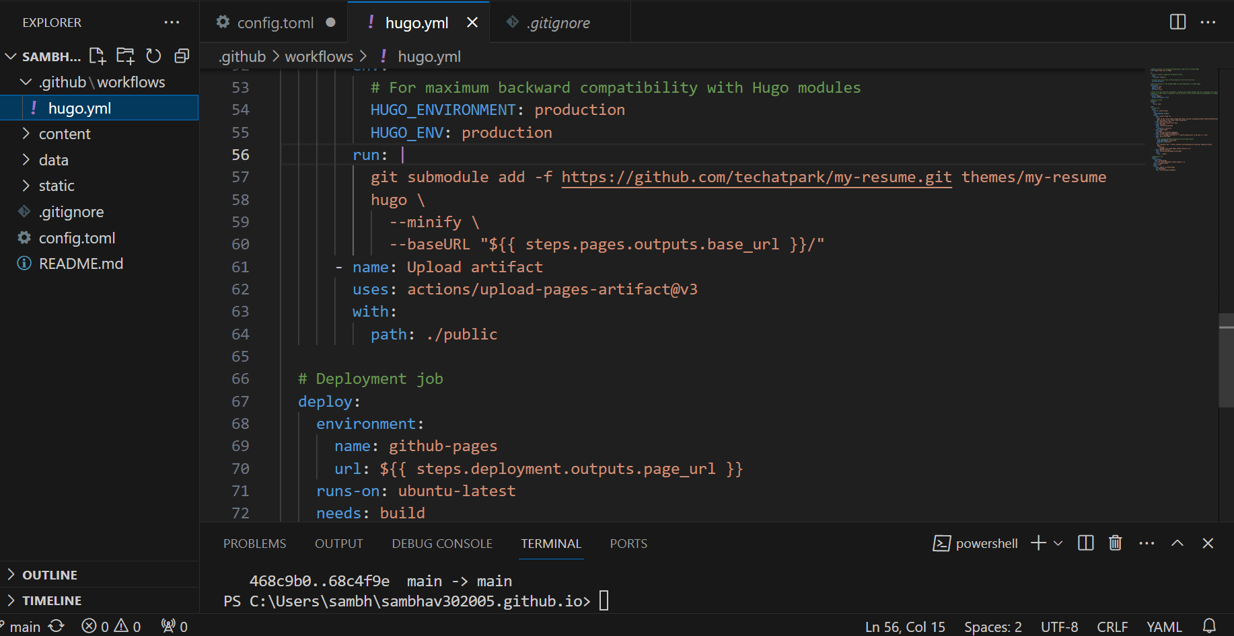

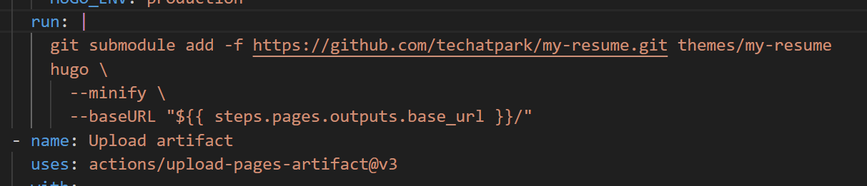

Add this

………………………………………………….

git add .

git commit -m"Message for your refrence"

git push

………………………………….in terminal………………..